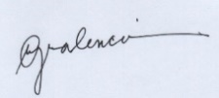
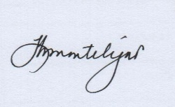


11

General Mathematics
Activity Sheets
Quarter 2 – MELC 5

Illustrating Simple and General Annuities


REGION VI – WESTERN VISAYAS

General Mathematics 11 Activity Sheet No. 05
First Edition, 2020

Published in the Philippines
By the Department of Education Region 6 – Western Visayas

Republic Act 8293, section 176 states that: No copyright shall subsist in any work of the Government of the Philippines. However, prior approval of the government agency or office wherein the work is created shall be necessary for exploitation of such work for profit. Such agency or office may, among other things, impose as a condition the payment of royalties.

This Learning Activity Sheet is developed by DepEd Region 6 – Western Visayas.

ALL RIGHTS RESERVED. No part of this learning resource may be reproduced or transmitted in any form or by any means electronic or mechanical without written permission from the DepEd Regional Office 6 – Western Visayas.
Development Team of General Mathematics Activity Sheet Writer: Rutchel J. Ngipen
Illustrator: Rutchel J. Ngipen

Layout Artist: Rutchel J. Ngipen

Schools Division Quality Assurance Team:
Ligaya H. Montelijao, EPS-Mathematics
Leila G. Valencia, EPS-LR
Jezereel Grace G. Tiron
Bernie P. Alcedo
Division of Iloilo City Management Team:
Ma. Luz M. De los Reyes, SDS
Ernesto F. Servillon Jr., ASDS
Arlo L. Villalva, CID Chief
Dr. Jerry M. Lego, SGOD Chief
Leila G. Valencia, EPS-LR
Ligaya H. Montelijao, EPS-Mathematics
Regional Management Team
Ma. Gemma M. Ledesma, Dr. Josilyn S. Solana,
Dr. Elena P. Gonzaga, Mr. Donald T. Genine, Mr. Adonis Mosquera
Mrs. Rhodalyn Delcano

Introductory Message

Welcome to General Mathematics 11!

The Learning Activity Sheet is a product of the collaborative efforts of the Schools Division of Iloilo City and DepEd Regional Office VI - Western Visayas through the Curriculum and Learning Management Division (CLMD). This is developed to guide the learning facilitators (teachers, parents and responsible adults) in helping the learners meet the standards set by the K to 12 Basic Education Curriculum.

The Learning Activity Sheet is self-directed instructional materials aimed to guide the learners in accomplishing activities at their own pace and time using the contextualized resources in the community. This will also assist the learners in acquiring the lifelong learning skills, knowledge and attitudes for productivity and employment.




For learning facilitator:

The General Mathematics Activity Sheet will help you facilitate the teaching-learning activities specified in each Most Essential Learning Competency (MELC) with minimal or no face-to-face encounter between you and learner. This will be made available to the learners with the references/links to ease the independent learning.




For the learner:

The General Mathematics Activity Sheet is developed to help you continue learning even if you are not in school. This learning material provides you with meaningful and engaging activities for independent learning. Being an active learner, carefully read and understand the instructions then perform the activities and answer the assessments. This will be returned to your facilitator on the agreed schedule.

Learning Activity Sheets (LAS) No. 5
Quarter 2, Week 3

Name of Learner: ___________________ Grade and Section: _________________
Date: _____________________________

GENERAL MATHEMATICS ACTIVITY SHEET
Illustrating Simple and General Annuities

- Learning Competency with Code
Illustrates simple and general annuities. (M11GM-IIc-1)

- Background Information for Learners
There are many practical examples of financial transactions involving installments, such as car loan being repaid with equal monthly installments, a retiree purchasing a pension plan from an insurance company upon his retirement, a life insurance policy being purchased with monthly premiums, or a bondholder receiving an income in the form of semi-annual coupon payments. These are examples of payments by installment which are done periodically, and equal in amounts.
This payments scheme is called annuity, which can be used to accumulate funds (e.g. when you make regular deposits in a savings account) or to pay out funds (e.g. when you receive payments from pension plan after you retire).
Annuities, according to payment interval and interest period, can be classified into two ways simple annuity and general annuity.

Important Terminologies:
- Annuity, A – a sequence of payments made at equal (fixed) intervals or periods of time
- Payment interval, n – the time between successive payments
- Term of an annuity, t – time between the first payment interval and last payment interval
- Regular or Periodic payment, R – the amount of each payment
- Amount (Future Value) of an annuity, F – sum of future values of all the payments to be made during the entire term of the annuity
- Present value of an annuity, P – sum of present values of all the payments to be made during the entire term of the annuity
- Simple Annuity – an annuity where the payment interval is the same as the interest period
- General Annuity – an annuity where the payment interval is not the same as the interest period
- Ordinary Annuity (Annuity Immediate) – a type of annuity in which the payments are made at the end of each payment interval
- Annuity Due – a type of annuity in which the payments are made at the beginning of each payment interval
- Annuity Certain – a type of annuity in which payments begin and end at definite times
- Contingent Annuity – an annuity in which the payments extends over an indefinite (or indeterminate) length of time

Illustration of Simple and General Annuity:

- Simple Annuity

Example 1: Suppose Rodrigo, a high school student, would like to save ₱5,000 annually in a fund that gives 10% compounded annually. How much is the amount or future value of his savings after 4 years?

Solution: Use the cash flow time diagram and compounding interest formula F = $P{\left(1+\frac{r}{n}\right)}^{nt}$to illustrate the annuity.
Future Value (F) = ₱23,205
₱5,000${\left(1+\frac{0.10}{1}\right)}^{1(0)}$ = ₱5,000
₱5,000${\left(1+\frac{0.10}{1}\right)}^{1(1)}$ = ₱5,500
₱5,000${\left(1+\frac{0.10}{1}\right)}^{1(2)}$ = ₱6,050
₱5,000${\left(1+\frac{0.10}{1}\right)}^{1(3)}$ = ₱6,655

₱5,000
₱5,000
₱5,000
₱5,000
4
0
3
1
2
1 year
1 year
1 year
1 year
P
F
years

Therefore, the amount of his savings after 4 years is ₱23,205.

Example 2: How much money should you invest today in an account that earns 5% compounded monthly in order to withdraw ₱10,000 every month for 6 months?

Solution: Use the cash flow time diagram and compounding interest formula P = $\frac{F}{{\left(1+\frac{r}{n}\right)}^{nt}}$ to illustrate the annuity.
₱10,000
4
0
3
1
2
6
1 mo
1 mo
1 mo
1 mo
1 mo
5
1 mo
₱10,000
₱10,000
₱10,000
₱10,000
₱10,000
P
F
₱9,523.81 = ${₱10,000}/{{\left(1+\frac{0.05}{1}\right)}^{1(1)} }$
₱9,070.29 = ${₱10,000}/{{\left(1+\frac{0.05}{1}\right)}^{1(2)} }$
₱8,638.38 = ${₱10,000}/{{\left(1+\frac{0.05}{1}\right)}^{1(3)} }$
₱8,227.02 = ${₱10,000}/{{\left(1+\frac{0.05}{1}\right)}^{1(4)} }$
₱7,835.26 = ${₱10,000}/{{\left(1+\frac{0.05}{1}\right)}^{1(5)} }$
₱7,462.15 = ${₱10,000}/{{\left(1+\frac{0.05}{1}\right)}^{1(6)} }$

₱50,756.91 = Present Value (P)
months

Therefore, the amount that you should invest is ₱50,756.91.

- General Annuity

Example 1: Suppose Rodrigo change his mind and decided to save ₱5,000 annually in a fund that gives 10% compounded semi- annually. How much is the amount or future value of his savings after 4 years? Will he regret his decision of changing his investment?
Solution: Use the cash flow time diagram and compounding interest formula F = $P{\left(1+\frac{r}{n}\right)}^{nt}$to illustrate the annuity.
Future Value (F) = ₱23,290.51
₱5,000${\left(1+\frac{0.10}{2}\right)}^{2(0)}$ = ₱5,000
₱5,000${\left(1+\frac{0.10}{2}\right)}^{2(1)}$ = ₱5,512.50
₱5,000${\left(1+\frac{0.10}{2}\right)}^{2(2)}$ = ₱6,077.53
₱5,000${\left(1+\frac{0.10}{2}\right)}^{2(3)}$ = ₱6700.48

₱5,000
₱5,000
₱5,000
₱5,000
4
0
3
1
2
P
F
6 months 6 mo.
6 months 6 mo.
6 months 6 mo.
6 months 6 mo.
years

Therefore, the amount of his savings after 4 years is ₱23,290.51

Example 2: How much money should you invest today in an account that earns 5% compounded quarterly in order to withdraw ₱10,000 every year for 4 years?

Solution: Use the cash flow time diagram and compounding interest formula P = $\frac{F}{{\left(1+\frac{r}{n}\right)}^{nt}}$ to illustrate the annuity.
₱10,000
4
0
3
1
2
₱10,000
₱10,000
₱10,000
P
F
₱9,515.24 = ${₱10,000}/{{\left(1+\frac{0.05}{4}\right)}^{4(1)} }$
₱9,053.98 = ${₱10,000}/{{\left(1+\frac{0.05}{4}\right)}^{4(2)} }$
₱8,615.09 = ${₱10,000}/{{\left(1+\frac{0.05}{4}\right)}^{4(3)} }$
₱8,197.46 = ${₱10,000}/{{\left(1+\frac{0.05}{4}\right)}^{4(4)} }$

₱35,381.77 = Present Value (P)
years
Every 3 months
Every 3 months
Every 3 months

Every 3 months

Therefore, the amount that you should invest is ₱35,381.77.

- Accompanying DepEd Textbook and Education Sites
https://www.worldscientific.com/doi/pdf/10.1142/9789813224681_0002
https://www.youtube.com/watch?v=iYghPrs7JtM
https://www.youtube.com/watch?v=Xt0kh8VGF-I
General Mathematics Learner's Materials. Pasig City: Department of Education - Bureau of Learning Resources, 2016, pp 168-204

- Activity Proper
General Directions: In answering the exercises in the Learning Activity Sheet (LAS), please be reminded not to write anything here. All answers must be written in a separate sheet of paper. Read each problem carefully and answer it systematically. If solution is required, encircle your final answer.
Exercise 1: Miriam borrowed money and promised to cancel her debt 5 years by paying ₱3,500 at the end of each year with interest at 4% compounded annually.
- Draw and fill in ( ) to complete the cash flow time diagram Miriam should follow to be able to reach her goal

P
years

F

- Miriam changed her goal and decided to pay ₱4,000 at 4% compounded semi-annually, complete her new cash flow time diagram.
P
years

F

Guide Questions:
- What type of annuity is being described by the cash flow time diagram in Exercise 1.a?
- What type of annuity is being described by the cash flow time diagram in Exercise 1.b?
- What are the important data that you need in illustrating annuity?

Exercise 2: Study and illustrate the cash flow time diagram of the annuity being referred to by the following problem:
- Peter started to deposit ₱5,000 monthly in a fund that pays 1% compounded monthly. How much will be in the fund after 8 months?
- Ann’s parents are planning for a house lease agreement. How much money will they prepare in a house that has 6% interest rate compounded annually in order to pay ₱30,000 semi-annually for 5 years?

Guide Question:
- What is your first step in illustrating an annuity problem?
- What steps did you come up with to illustrate either the future value or present value in the problem?
- Which of the following showed simple annuity? general annuity?

- Reflection
Instruction. Reflect on the following questions and write your response on your journal.
- Why is it necessary to illustrate annuity structure or arrangements?
- What is the importance of knowing whether the problem or situation is simple annuity or general annuity?
- What values have been embedded to you by the process of illustrating annuity?
- Answer Key

Exercise 1.a

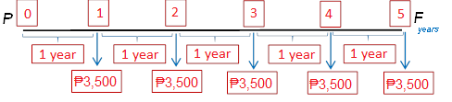

Exercise 1.b

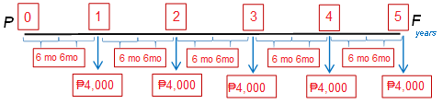

Exercise 2.a
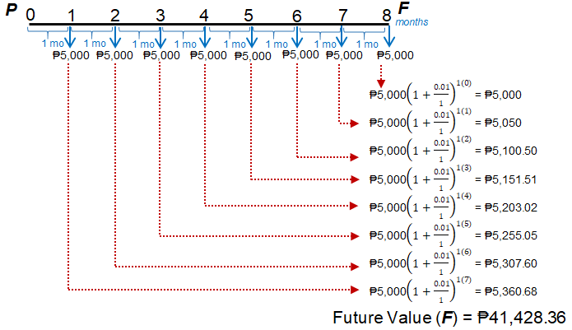

Exercise 2.b

